

CAREERS SUPPORT GUIDE
Dorset

Employment – Training – Education – Volunteering

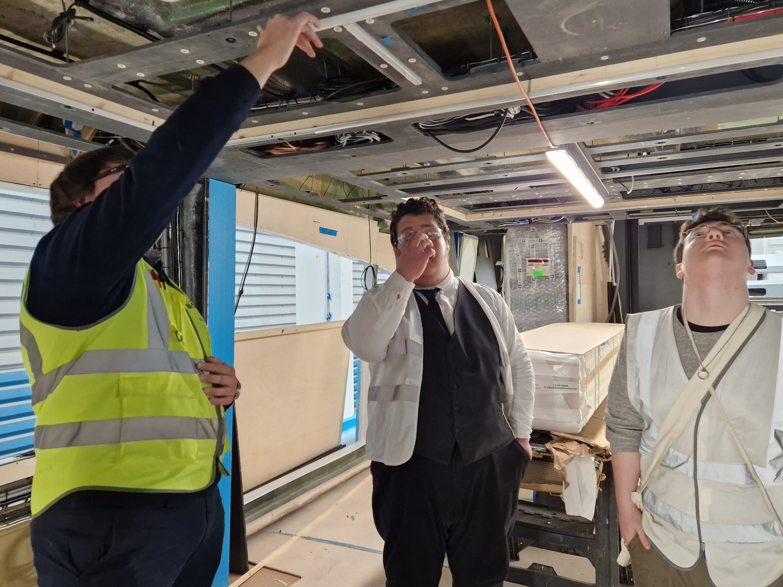

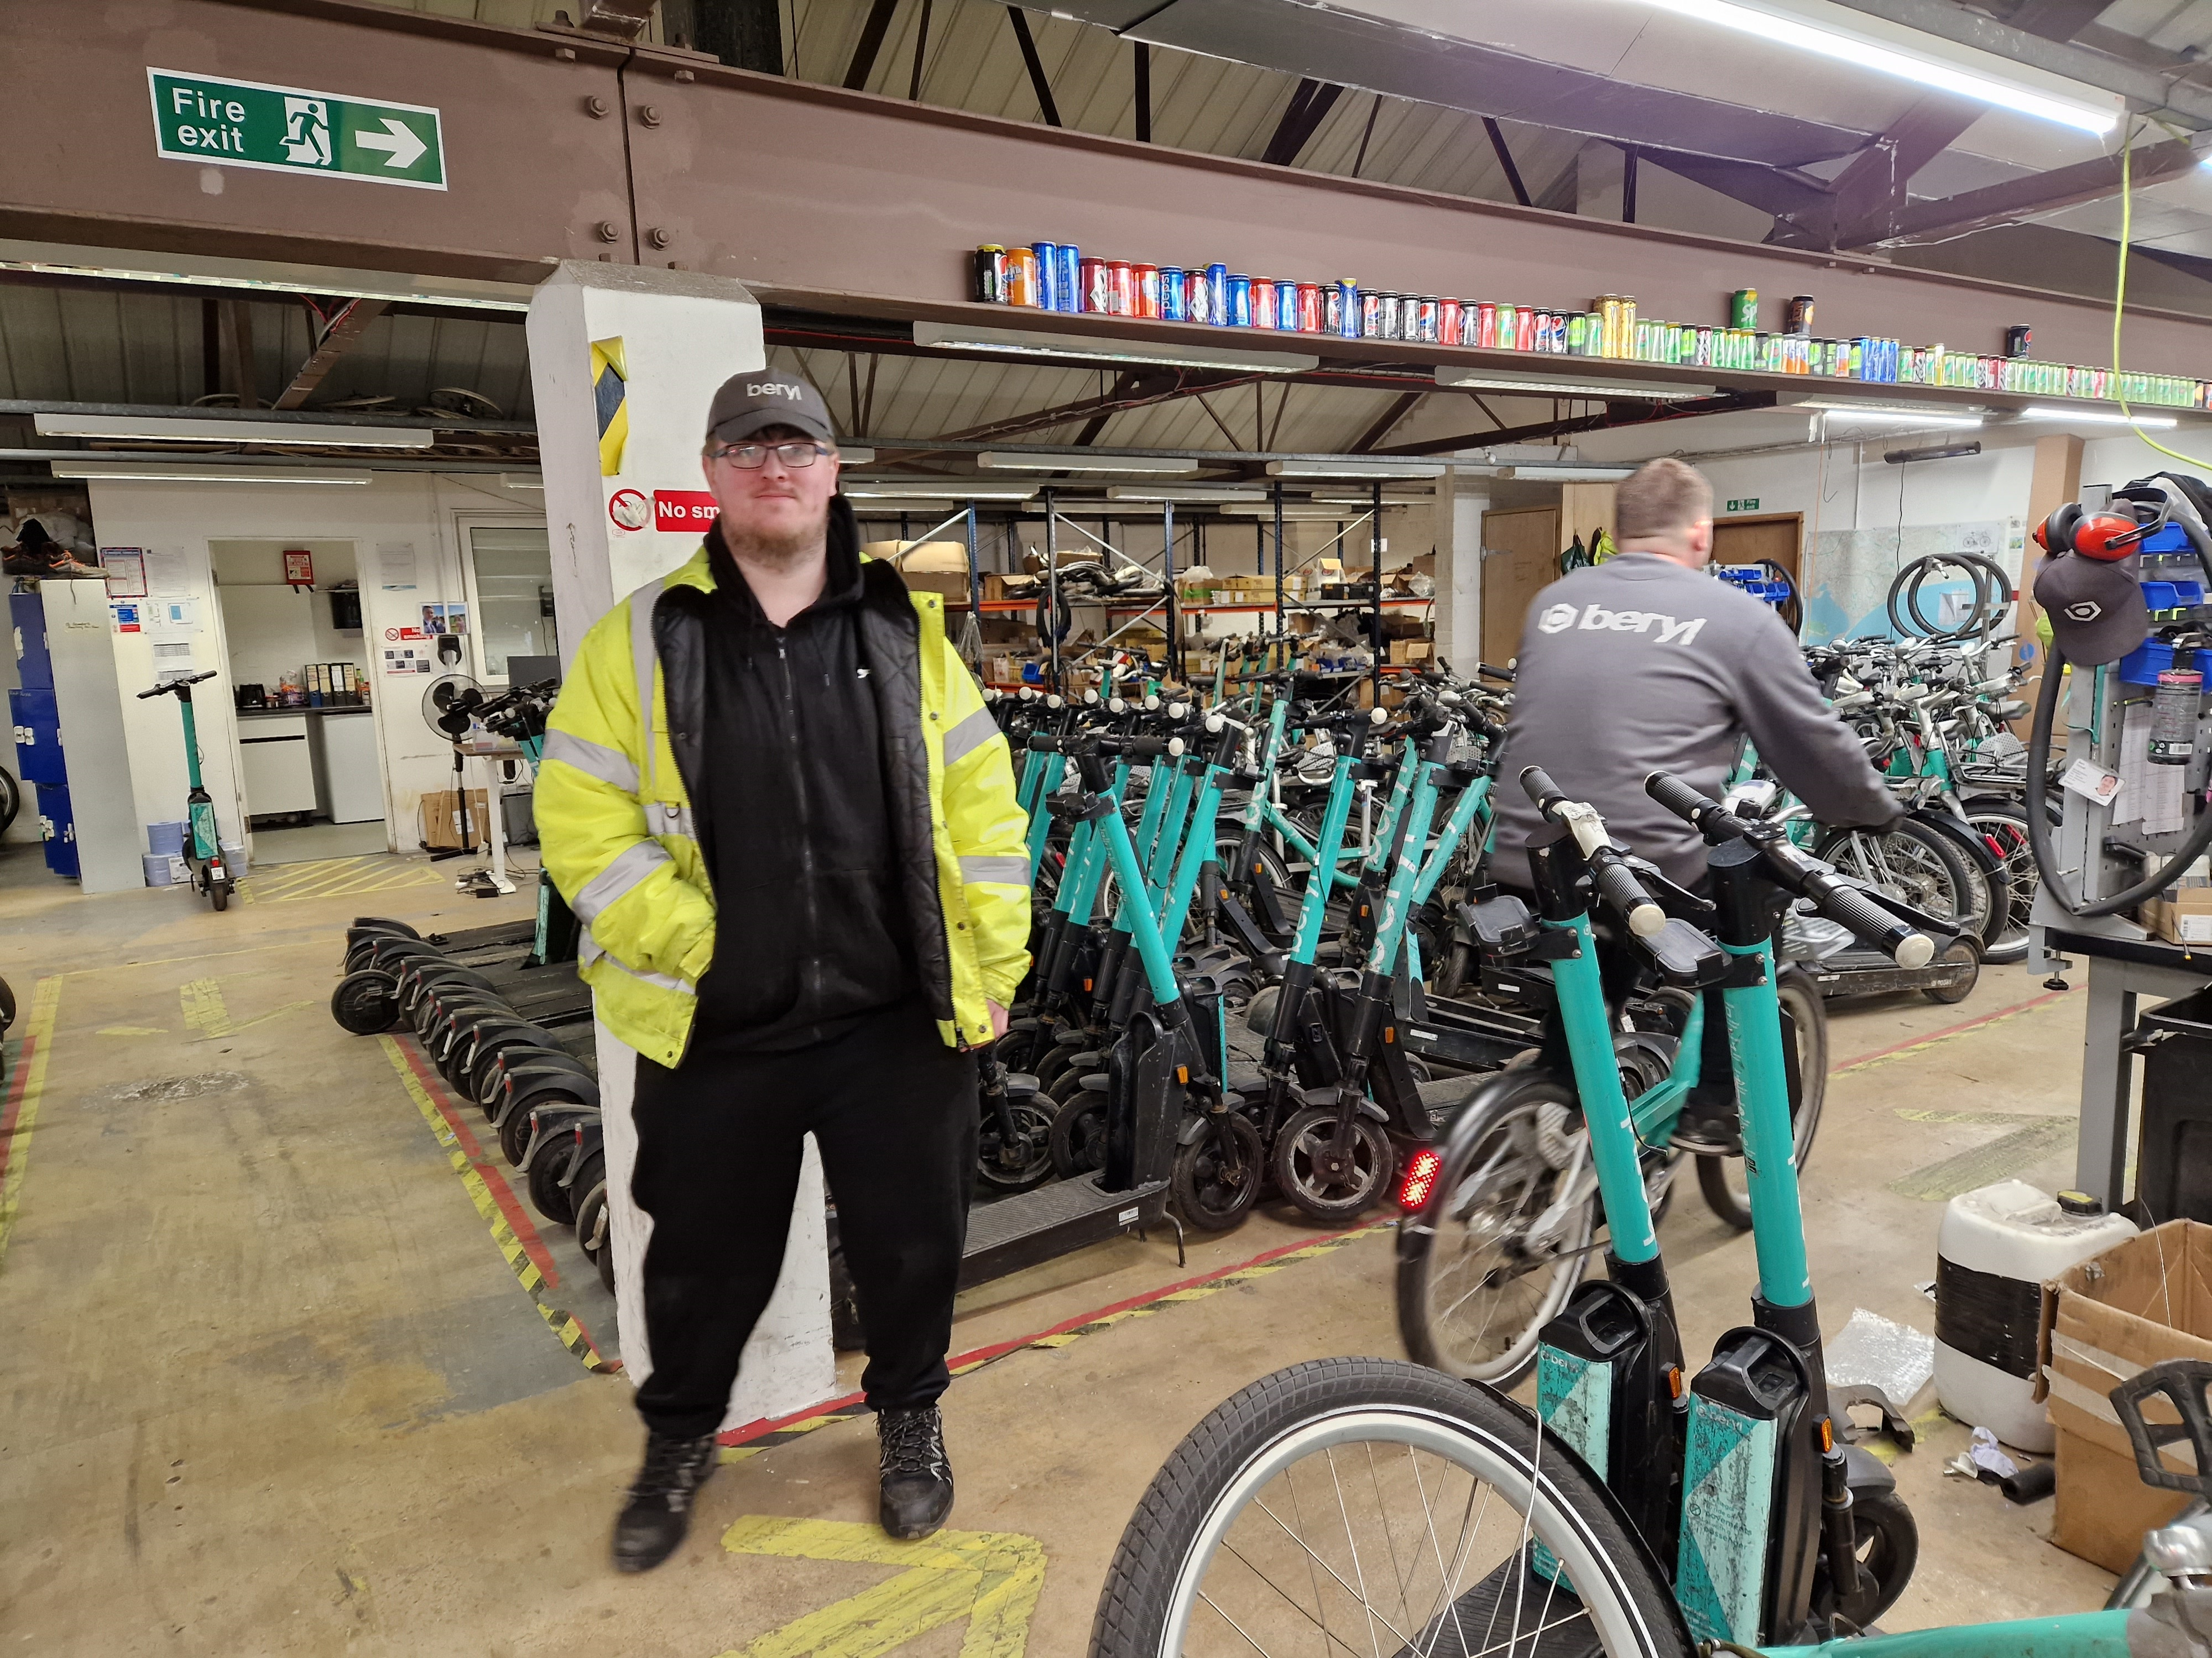



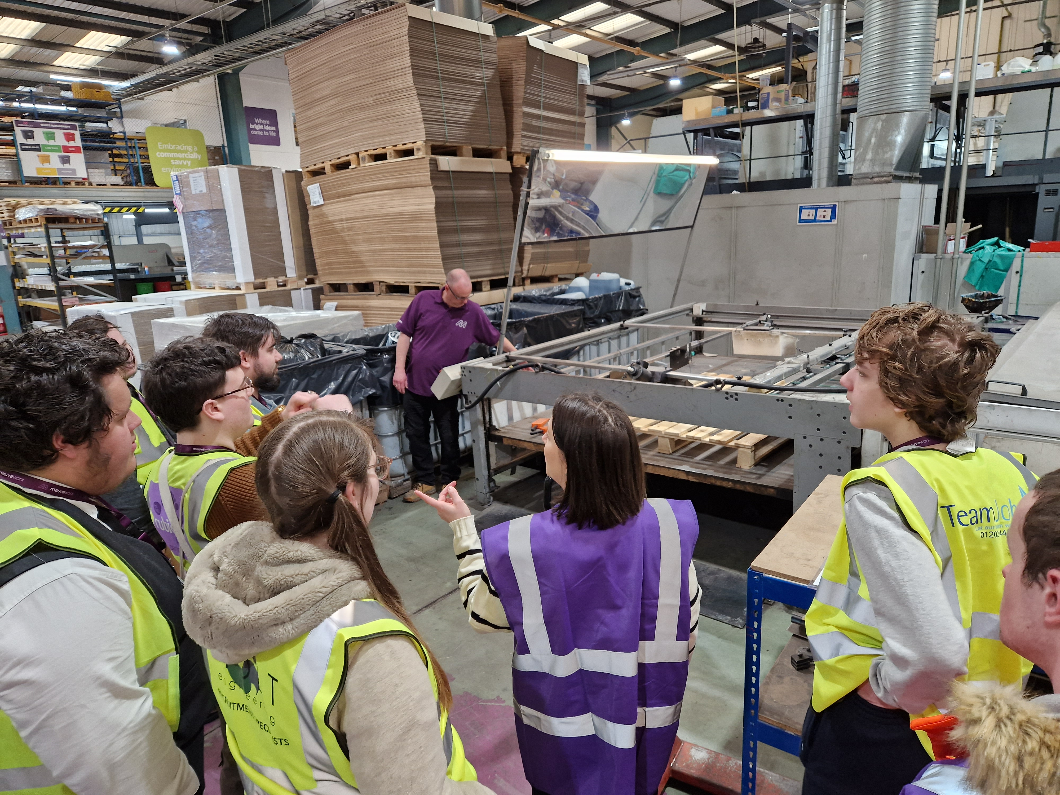





CONTENTS

Section 1 What is Careers Information, Advice and Guidance?

Section 2 How to find out about different jobs

Section 3 Qualifications Table

Section 4 Options:
- Education (college and uni)
- Employment and self-employment
- Supported Internships and Apprenticeships
- Volunteering

Section 5 Getting a Job or Apprenticeship
- Create a CV
- Job Searching
- Interview Skills

Section 6 Support after SWRAC
- Careers Guidance
- Benefits and Job Hunting
- Access to Work

SECTION 1:
What is Careers Education, Information, Advice and Guidance (or CEIAG for short)?

Careers:
- Education to find out what exists in the world of work
- Information on the local labour market, education and training options
- Advice on specific routes into career choices tailored to you
- Guidance more in-depth exploration, tailored to your needs helping you explore your ideas, strengths, skills, interests, etc, encouraging you to make decisions you are happy with. This puts YOU in the driving seat.

Preparing to see your Careers Adviser
- Be willing to participate.
- Come with ideas.
- Come with an open mind.
- Think about what you are good at.
- Think about what you enjoy.
- Don’t expect to be told what to do.
- This is your journey, not a destination!

SECTION 2:
How to find out about different jobs

“You can’t be what you can’t see!”


Careers Information Websites:
Careers information on the range of different industries and occupations (jobs).
Learn about what’s involved, what skills are needed, how much you can expect to earn and lots more.

JED (Job Explorer Database) – information is in your Careers Portfolio

Career Pilot – www.careerpilot.org.uk
- Start with You
  - Quiz – this can help to get you thinking about what you might like in a job.
  - What’s important to you – look at jobs that fit with your own values
  - By subject – if you love a particular subject, search jobs that use that subject
  - By sector – search jobs by the particular sector or industry

- Job Profiles:
  - Show average salary, hours and future prospects of a job
  - General overview of the job
  - Different entry routes into the job
  - Live vacancies – job adverts which give you greater insight into the work
  - Video clips – these are between around 4-6 minutes long and are by people doing the jobs.
  - Skills listed that are needed for the job

Planit Plus - www.planitplus.net
Similar to Career Pilot, but sometimes with more information and different videos

Talk to people doing the job already
- What do they do
- How did they get into this
- What do they like / not like about their job

SECTION 3:
Qualifications Table

Level | Academic Qualification | Vocational Equivalent | Work Based
8 | Doctor of Philosophy (PhD)  Scottish equivalent: Higher 12
7 | Master’s degree (eg, MA, MSc, MEng)  Scottish equivalent: Higher 11 |  | Master’s Degree Apprenticeship  NVQ Levels 7
6 | Year 3 – 4 - Degree  Scottish equivalent: Higher 9-10 | Degree may include 1 year in industry | Degree Apprenticeship  NVQ Levels 6
5 | Year 2 - Degree  Scottish equivalent: Higher 8 | HND  Year 2 - Foundation Degree | Higher / Degree Apprenticeship  NVQ Levels 5
4 | Year 1 - Degree  Scottish equivalent: Higher 7 | HNC  Year 1 - Foundation Degree | Higher / Degree Apprenticeship  NVQ Levels 4
3 | A Levels  2-year course  Scottish equivalent: Higher 6 | T-Levels  2-year course | Advanced Apprenticeship  NVQ Level 3
2 | GCSE grades 9-4 (A*-C)  Grade 5 – strong pass, grade 4 standard pass  Scottish equivalent: National 5 | Vocational courses / Pre T-Levels | Intermediate Apprenticeships  NVQ Level 2
1 | GCSE grades 3-1 (D-G)  Functional Skills at Level 1  Scottish equivalent: National 4 | College courses in work-related subjects | Supported Apprenticeships
Entry Levels  (1, 2, 3) |  |  | Supported Internships

Information source:
https://qualifications.pearson.com/en/support/support-topics/understanding-our-qualifications/framework-rqf.html/student.html

SECTION 4: Options
Further Education (college)

College offer courses at all levels of ability, so there is usually a course to suit you. To find out more:

- Use websites
- Attend college Open days
- Ask about doing a Shadowing Day – try the course before you sign up.
- Apply online from September the year before you want to start.
- Attend the interview
- Accept your place even if you are not sure as this holds it for you until enrolment.
- Make your final decision to accept the place when you enrol September.

College | Contact | Levels offered
Bournemouth & Poole College  Broad range of vocational subjects available | 01202 205205  www.thecollege.co.uk | - Foundation Level Courses  - Vocational Courses to Level 3
Brockenhurst College, New Forest  Broad range of vocational subjects available | 01590 625555  www.brock.ac.uk | - Foundation Level Courses  - Vocational Courses to Level 3  - A Levels
Kingston Maurward College, Dorchester  Mainly agriculture, plants and animals | 01305 215000  www.kmc.ac.uk | - Foundation Level Courses  - Vocational Courses to Level 3
Sparsholt College, Winchester  Mainly agriculture, plants and animals | 01962 776441  www.sparsholt.ac.uk | - Foundation Level Courses  - Vocational Courses to Level 3  - Higher Education (degree)
Totton College, Nr Southampton Broad range of vocational subjects available | 02380 874874  www.totton.ac.uk | - Foundation Level Courses  - Vocational Courses to Level 3
Weymouth College, Dorset  Broad range of vocational subjects available | 01305 761100  www.weymouth.ac.uk | - Foundation Level Courses  - Vocational Courses to Level 3  - A Levels
Yeovil College, Somerset  Broad range of vocational subjects available | 01935 423921  www.yeovil.ac.uk | - Foundation Level Courses  - Vocational Courses to Level 3  - A Levels

Adult Learning – 19+
Are you interested in part time learning? You may wish to learn new skills or gain those English and Maths qualifications that you missed out on before.

Learndirect offer Functional Skills Maths and English Entry Level 1 to Entry Level 3 online for free for any age. Level 1 and level 2 incur a charge. https://www.learndirect.com/

Skills and Learning https://www.skillsandlearningace.com/
Many colleges also offer part time
Higher Education (university)

Thinking about university?
- Speak to your careers adviser
- Look at www.ucas.com
- Look at www.open.ac.uk

Here are the local universities and colleges offering HE. However, you will need to research further than your local area when considering this option.

University | Website
Arts University Bournemouth | https://aub.ac.uk/
Bournemouth University | https://www.bournemouth.ac.uk/
Brockenhurst College | https://www.brock.ac.uk/higher-education/
Bournemouth & Poole College | https://www.thecollege.co.uk/degree-level
Kingston Maurward College | https://www.kmc.ac.uk/
Southampton Solent University | https://www.solent.ac.uk/
Sparsholt College | https://www.sparsholt.ac.uk/university-centre/

For more information, speak to your careers adviser or go to
- www.gov.uk/higher-education-courses-find-and-apply
- www.ucas.com

As an alternative to university, why not consider higher level apprenticeships. These are in the next section.

Supported Internships and Apprenticeships

Supported Internships
Training for those with EHCPs who are not ready for a full apprenticeship.
- Part time work, part time education
- Job coaches to help you
- Gain more work skills
- May lead to paid employment where opportunities exist

Apprenticeships: what are they?
- 20% of your time will be in training.
- You get paid a training wage.
- You achieve a professional qualification.
- You don’t always need qualifications to get an apprenticeship.

Apprenticeship Levels
- Intermediate Level 2 (same as GCSEs at grades 4-9)
- Advanced Level 3 (same as A Levels)
- Higher Levels 4 & 5 (same as foundation degree)
- Degree of Post Graduate Levels 6 & 7 (a degree or master’s degree)

Apprenticeship Vacancies
- Go to www.apprenticeships.gov.uk
- Click on Become an Apprentice
- Click on Browse Apprenticeships
- Choose your area of interest
- Put in your postcode
- Look through vacancies and click on those of interest.
- Read through the details and decide if its what you are interested in.
- Apply for all that appeal to you
- Once you create an account, you will receive updates.

You can also look at:
- Amazing Apprenticeships – www.amazingapprenticeships.com
- UCAS – www.ucas.com/apprenticeships-uk

Local Apprenticeships Providers

Vocational areas covered by some local training providers and their contacts

Provider Name: | Aspire | B & P College | HIT | Kingston Maurward College | Paragon Skills | Peta | Sparsholt College
Accountancy |  |  |  |  | x |  | x
Adult Care |  |  |  |  | x
Animal Care & Equine |  |  |  | x |  |  | x
Automotive |  | x |  |  | x
Business Admin | x | x | x | x | x | x | x
Childcare and Education | x |  |  |  | x
Construction |  | x
Countryside Management |  |  |  | x |  |  | x
Customer Service / Experience | x |  |  |  | x
Digital, Computing & IT |  | x |  |  |  | x
Engineering |  | x |  |  |  | x
Event Management
Hair and Beauty |  | x |  |  | x
Health, Care & Education |  | x
Horticulture |  |  |  | x |  |  | x
Hospitality & Catering | x | x | x |  | x
Leadership & Management |  |  |  |  | x | x | x
Marine |  | x |  |  | x
Sales |  |  |  |  | x
Retail |  |  | x
Talent Management |  |  |  |  | x
Theatrical Make up |  | x

Provider | Website
Aspire | www.aspiretrainingteam.co.uk
Bournemouth & Poole College | www.thecollege.co.uk/apprenticeships
HIT Training | https://hittraining.co.uk/
Kingston Maurward College | https://www.kmc.ac.uk/college/courses/apprenticeships/
Paragon Skills, Boscombe | https://paragonskills.co.uk/
Peta | www.peta.co.uk
Sparsholt College, Winchester | https://www.sparsholt.ac.uk/apprenticeships/
Weymouth Collee | https://www.weymouth.ac.uk/level-of-study/apprenticeships/
Yeovil College | https://www.yeovil.ac.uk/apprenticeships/current-vacancies/

Employment

Types of employment
- Full time – usually 40 hours per week
- Part time – anything up to full time
- Permanent – the job is yours until you choose to leave
- Temporary, eg maternity cover, holiday cover, for a set project
- Zero hours – allocated to an organisation that will provide work when they need you. No guarantee of hours and therefore no guarantee of salary.
- Self-Employment – your own boss

Minimum Wage
The rates which will apply from 1 April 2026 are as follows:
 | National Minimum Wage Rate
National Living Wage (21 and over) | £ 12.71
18–20-Year-Old Rate | £ 10.85
16–17-Year-Old Rate | £ 8
Apprentice Rate | £ 8

This increases each year. For the latest information, check https://www.gov.uk/national-minimum-wage-rates

Self-Employment

You are your own boss!
There is no minimum wage – that’s down to you to earn your money (and pay your tax, national insurance and pension contributions).
There are no particular hours – you choose the hours you work.

If you like the idea of being your own boss, you can use Career Pilot to find out more:

www.careerpilot.org.uk
- Click on Explore Your Options
- Click on Choices at 18+
- Click on Help with Employment and Self Employment
- Click on Find out about Entrepreneurship and Self Employment

Also, look at the following websites:

- Digital Skills Hub, Royal Arcade, Boscombe – Drop in Mondays 2pm-4pm https://www.digitalskillshub.org.uk/business-connect-mondays

- Dorset County Council – Starting up and running a business
https://www.dorsetcouncil.gov.uk/business-consumers-licences/business-support-and-advice

- Federation of Small Businesses - https://www.fsb.org.uk/

- Government - https://www.gov.uk/working-for-yourself

- SAMEE – https://samee.co.uk
SAMEE support people with disabilities to set up their own businesses.

- Prince’s Trust - https://www.princes-trust.org.uk/how-we-can-help/support-starting-business
Prince’s Trust help people aged 18-30 to set up their own businesses.

Volunteering

Benefits of volunteering:
- Gain transferrable skills for the workplace.
- Try something you may not try otherwise.
- Gain a new hobby or interest.
- Make new friends.
- Open up new opportunities for career ideas.
- Opportunities to travel.
- Looks good to potential employers.
- Builds confidence and a sense of achievement.

Where to look for volunteering – useful websites

Locally / in the UK
BCHA | https://www.bcha.org.uk/
CAN100 | https://www.can100.org/  Drop in at the Digital Skills Hub, Royal Arcade, Boscombe on Tuesdays between 2pm and 4pm to find out more about volunteering
Dorset volunteering | www.volunteeringdorset.org.uk
Gov.UK | www.gov.uk/government/get-involved/take-part/volunteer
Bournemouth Hospital | https://www.uhd.nhs.uk/hospitals-bournemouth
Poole Hospital | https://www.poole.nhs.uk/
Dorchester Hospital | www.dchft.nhs.uk
Poole Culture Volunteers | www.poole.gov.uk
Reach Volunteering | www.reachvolunteering.org.uk
Volunteering Matters | www.volunteeringmatters.org.uk

Examples of overseas volunteering opportunities
Bunac | www.bunac.org/uk/volunteer-abroad
Camp America | www.campamerica.com

Does it cost money to volunteer?
Check with each organisation as there may be costs, eg, transport or accommodation.

Section 5:
Getting a Job or Apprenticeship

Creating a CV

This is your personal marketing tool. It needs to be a good advert showing your skills, abilities, qualifications and work-related interests.

Formatting your CV
- Use bullet points – these are easy for the employer to scan.
- Tab across to put in the date rather than using the space bar. This ensures that your dates line up neatly.
- Use clear headings and make sure the style is consistent.

General dos and don’ts
- Don’t write CV or Curriculum Vitae at the top! It’s obvious what it is.
- Do write the name you prefer to be known by rather than your full name.
- Do use a formal email address if you don’t have one already,
eg, andy-jones123@hotmail.co.uk.
- Don’t include you date of birth.
- Don’t include names of referees.
- Do make sure you get across your skills, qualifications and abilities, market yourself well but tell the truth.
- Don’t have any spelling mistakes or grammatical errors or typos.
- Do keep it short and to the point – 2 pages max.
- Do print on good quality paper, one sided, do not fold unless putting in an envelope.

Sections of your CV

First Name and Surname
Area you live, eg, Bournemouth
Phone number
Email

PERSONAL PROFILE
This is a brief description of the kind of person you are; what you have to offer the company; and what you are looking for in relation to your job hunting.

Example – DO NOT COPY THIS and when you have written your own, delete this!
An organised, practical and motivated team worker with experience gained from working in with BCP Council on a supported internship. This included placements with Beryl Bikes, highways and the amusement arcade. I am seeking employment, ideally with training in a practical role where I can use the skills I have gained and build on these to develop my career.

KEY SKILLS AND ACHIEVEMENTS
- Key skill
- Key skill
- Key skill
- Key skill
- Key skill

Example - DO NOT COPY THIS and when you have written your own, delete this!
- customer service skills, awarded employee of the week
- teamworking skills used in work experience when building a den, I held the ropes whilst other team members put up the coverings

WORK EXPERIENCE
Company Name Month year to Month year
Length of placement, eg one day per week for a year
Job Title
- task
- task
- task
- task

Company Name Month year to Month year
Length of placement, eg one day per week for a year
Job Title
- task
- task
- task
- task

EDUCATION AND QUALIFICATIONS
SWRAC Month year to Month year
Course
- Qualification and level
- Qualification and level
- Qualification and level
- Qualification and level

College Name Month year to Month year
Course
- Qualification and level
- Qualification and level

School Name Month year to Month year
Achieved the following GCSEs:
- English, grade
- Maths, grade
- Science, grade
- Subject, grade
- Subject, grade
- Subject, grade

INTERESTS
Keep this relevant to the job, or interesting.

CV Examples
Jane Smith
Bournemouth
Email: name-name@hotmail.co.uk
Phone: 07979 123456

PERSONAL PROFILE
A reliable, self-motivated and friendly individual with a passion for helping others, I work well as part of a team, I love meeting new people and am really keen to get involved and make a difference. I am looking for an apprenticeship in care work.

KEY SKILLS
- Customer service skills
- Waitressing skills
- Hardworking, organised and focused on the task in hand
- Excellent time keeping and attendance record
- Patient and understanding with others

WORK EXPERIENCE
Seaview Care Home, Bournemouth June – July 2022
3 week placement
- Working as part of a team to support the needs of the elderly and carrying out tasks as directed.
- Spending time chatting with and listening to the residents.
- Making and serving teas, coffees and cold drinks.
- Taking part in activities, including singing, arts and crafts and afternoon tea.
- Ensuring everywhere is clean and tidy.

The Happy Café, Bournemouth March 2022
2 week placement
- Welcoming customers into the cafe.
- Taking orders and making teas, coffee and cold drinks.
- Preparing food in the kitchen - making sandwiches and cakes.
- Washing and drying up and generally keeping the café clean.

Heathlands Hotel June – July 2022
2 week placement
- Working as part of a team to restore the gardens and patio
- Weeding and clearing overgrown areas for planting
- Trimming shrubs back

EDUCATION AND QUALIFICATIONS
South West Regional Assessment Centre September 2021 – present
Traineeship (one year course)
- Maths Functional Skills, Level 1
- English Functional Skills, Level 1
- Employability, Level 1
- Customer Service, Level 1
- Health & Safety in the Workplace, Level 2

Vocational Programme (one year course)
- Maths Functional Skills, Entry Level 3
- English Functional Skills, Entry Level 3
- Vocational units in Animal Care, Care and Hair and Beauty

Bishop of Winchester Academy September 2016 – June 2021
Achieved GCSEs:
- English, grade 2
- Maths, grade 1
- Science, grade 1
- Art, grade 3

ACHIEVEMENTS
- Completing the National Citizenship Award, including raising money for charities Emily Star and Shelter.
- Gymnastic – over 30 Medals up to national level.
- Trampoline - over 20 Medals up to national level.
- Football – Played for AFC Bournemouth Ability Counts for 6 years and won Female Player of Season on 2 occasions.
- Member of Extraordinary Bodies Young Artist Theatre Group.

INTERESTS
I love dancing, the theatre, arts and crafts. I’m very sociable and like meeting new people. I am keen to support my community and do charity work.

Alex Draycott
Bournemouth
Phone number: 07897 123456
Email: alex.draycott100@gmail.com

PERSONAL PROFILE
A committed and enthusiastic team member who enjoys problem solving, working in a team environment, and completing tasks in a timely manner. I am keen to learn and develop my skills and experience through employment and am seeking a role in customer service.

KEY SKILLS AND ACHIEVEMENTS
- Good communication skills through speaking with a broad range of people of different ages and statuses.
- Helpful, friendly and sociable in offering good customer service.
- Excellent time management and organisational skills, completing tasks in a timely manner.
- Good analytical skills and attention to detail.
- Competent in using Microsoft Office: Word and PowerPoint and platform software, eg, Ibis paint, Photo Background Eraser, Polarr Photo Filters & Editor, Microsoft Windows.

EMPLOYMENT HISTORY
RedC Development May 2020 – July 2022
Carpentry Apprentice
- Helping to assemble stud partition walls.
- Installing doors and fitting door handles.
- Assembling floor joists and floor coverings.
- Fitting and installing window frames into stub work.
- Installing fascias and soffits.
- Installing banister spindles.

WORK EXPERIENCE
BCP Council September 2022 – July 2023
Beryl Bikes, Poole (3 months)
- Assisting bike mechanics by assembling parts ready for them to fit, including connecting wires to the frames for the motor and battery lock, assembling the baskets and the battery holders.
- Working in an organised manner and keeping the area clean and tidy.

Media Team Assistant (3 months)
- Working as part of a team to create the PROJECT Search Newsletter.
- Interviewing supported interns and recording their views and experience of PROJECT Search.
- Interviewing members of the council, including the CEO, about their experience of PROJECT Search.
- Writing articles for the newsletter and assisting with recording a video

VOLUNTEERING
Bournemouth Church Since 2018
- Welcoming people as they arrive at church on a Sunday morning and showing them to seats if needed, and checking the fire exits are kept clear.
- Checking the children / youth building and the church building have radios to enable contact in case of need.
- Helping set up for events, eg, weddings and group lunches.
- Generally ensuring the building is clean, tidy and toilets have toilet rolls in them.

EDUCATION AND QUALIFICATIONS
Project SEARCH: SWRAC and BCP Council September 2022 – July 2023
Supported Internship
- 70% in work placements – 3 across the year.
- 30% employability sessions to prepare for employment.

Bournemouth University September 2022 – March 2023
Graphic Design Short Course
Learning the basics of Photoshop, creating content, making gifs, product design

Corfe Hills School- Broadstone, Dorset January 2018 – June 2020
GCSEs
- Photography, grade 5
- Maths, grade 4
- Art, grade 4
- Science, grade 3, 3
- English, grade 3

BTEC
- Hospitality and Catering, Level 2

Functional skills
- English level 2
- ICT Level 2

INTERESTS
In my spare time, I like to go to the gym, working hard to build muscle. I recently started a graphic design course. I like creating illustrations and exploring other topics in the course and using photoshop.

Matt Johnson
Bournemouth
Email: name-name@gmail.com Phone: 07575 9876543

PERSONAL PROFILE
A well organised, methodical and reliable individual with several years of experience of stock replenishment and customer service, seeking paid employment in retail. I am particularly interested in developing a career in stock control and would also like to be trained to use the till.

KEY SKILLS
- Able to work unsupervised to a high standard using own initiative.
- Good customer service demonstrated through being friendly and helpful.
- IT skills include use of the Internet, Microsoft Word and Outlook.
- Reliable, hardworking and valuable team member
- Determined to achieve

WORK EXPERIENCE
Coop Ensbury Park February 2019 – present
1 day per week
- Identifying stock shortages and telling the supervisor of the shortage.
- Collecting stock from the warehouse and stacking shelves using stock rotation.
- Keeping shelves tidy.
- Guiding customers to correct aisles and shelves for products they are looking for.
- Working to Health and Safety Regulations.
- Helping to train new work experience people.

EDUCATION AND TRAINING
South West Regional Assessment Centre November 2018–November 2021
- Supported Internship (1 year)
- Prepare for Work (1 year)
- Prepare for Life (1 year)

Brockenhurst College September 2014 – June 2018
- Performing Arts, Entry Level 3
- Continuing Education
- Achieved English and Maths Level 1

Linwood School January 2008 – June 2014
- English and Maths Entry Level 2
- ICT Entry Level 3
- Physical Education Entry Level 1

INTERESTS
I enjoy completing DIY jobs at home, using my computer, accessing social media, and listening to a broad range of music. I am also a member of YMCA Chatterboxes, Bournemouth.

Job Hunting

Note re Social Media
When applying for jobs, employers may look you up on your Social Media, so make sure there is nothing there that might put the employer off you!

Where to look for jobs or apprenticeships
- Job search websites, such as Indeed, Total Jobs, Monster Jobs, etc
- Company websites – look for the ‘Careers’ link, often at the bottom of the page
- Job fairs and recruitment days
- Social media sites – Linked-In, Facebook, Twitter
- Cards in shop windows
- Through family or friends
- Speculation

General Vacancies – various jobs advertised
BCP Council | https://jobs.bcpcouncil.gov.uk/
Charity Jobs | www.charityjob.com
Daily Echo | www.sw1jobs.com/jobs
Dorset County Council | https://jobs.dorsetcouncil.gov.uk/
Fish for Jobs | www.fish4.co.uk/jobs/bournemouth
Gumtree | www.gumtree.com
Job Centre | www.gov.uk/find-a-job
Indeed | www.indeed.co.uk
Monster | www.monster.co.uk
Reed | www.reed.co.uk
Total Jobs | www.totaljobs.com

Examples of Industry Specific Job-Hunting Websites:
Construction / Engineering
Careers in Construction | www.careersinconstruction.com
Construction Jobs | www.constructionjobs.co.uk
Sunseeker | www.sunseeker.com/en/recruitment
Health and Social Care
Care Home | www.carehome.co.uk/jobs
Childcare Dorset | www.childcaredorset.co.uk
NHS | www.jobs.nhs.uk

Public Services
Army | www.army.mod.uk/careers/
Fire Service | www.fireservice.co.uk/recruitment
Navy | www.royalnavy.mod.uk/careers/
Police Force | www.joiningthepolice.co.uk
RAF | www.raf.mod.uk/recruitment/
RNLI | https://jobs.rnli.org
Retail / Customer Service
Retail Choice | www.retailchoice.com
Argos | www.argos.careers
Asda | www.asda.jobs
B&Q | www.diy.com/corporate/careers
Boots | www.boots.jobs
Lush | www.uk.lush.com/careers
Marks & Spencer | www.jobs.marksandspencer.com
Next | www.careers.next.co.uk
Primark | www.primark.com/en/careers/come-join-us
River Island | www.riverislandcareers.com
Royal Mail | www.jobs.royalmail.com
Sainsbury's | www.sainsburys.jobs
Screwfix | www.screwfixcareers.com
Superdrug | www.superdrug.jobs
Tesco | www.tesco-careers.com
TKMAXX | www.tkmaxx.com/careers
Don’t limit yourself to the above websites only!

Common Abbreviations used in Job Advertisements
DOE - depends on experience
O.T.E - on target earnings – (usually if working on commission)
P.A. - per annum/ per year
Pro Rata – proportion of full-time salary paid according to how many hours you work

How to Apply for Jobs
- Most jobs are advertised online.
- Some require a CV
- Some require just the application form.
- You may be able to copy information from your CV to the application form
- You may be able to upload your CV
- Sometimes you can contact a company with your CV to see if they have any jobs

How the recruitment process works
Advertised Jobs
- Complete the application form
- Upload your CV – if asked to
- Upload your covering letter – if asked to
- What is the company looking for?
  - Is the application form completed correctly?
    - Capital letters in the right places
    - No spelling mistakes
    - Followed instructions
    - All boxes completed
  - Is the information on the application form relevant to the job being advertised?
  - Does the person applying have the qualifications or skills required for the job?
  - Does the person have the experience required for the job?
- If successful on application, the employer will invite you to an interview, often by email, so check your spam folder
- If unsuccessful on application, you probably won’t hear anything!

Speculative Applications
- Here you apply to a company this is not currently advertising vacancies.
- Post / email them a copy of your CV with a covering letter asking if they have any vacancies which they think you might be suitable for.
- Apply to lots of companies!

Application Forms
- ALWAYS read the instructions and follow them!
- If there are guidance notes, read them too.
- If it is a paper-based application form, take a copy first in case you make a mistake.
- If it is online, try drafting your answers on a Word document and then copy them across.
- Use good English – correct punctuation, capital letters in the right places and full sentences.
- Complete all boxes, even if some don’t apply – just put n/a or not applicable in these.
- Don’t write ‘see CV’ but instead use you CV to help you complete the application form.
- Read the job description and apply your skills to the job they are advertising.
- Get someone to check your application before you submit it.
- Get your application submitted in plenty of time of the closing date.

Covering Letters and Emails
These are the first impression the employer has of you, so make sure you make a good impression. Be careful with emails not to be too informal.

Hints and Tips for Letter Writing
- ALWAYS use the name of the person you need to contact. It makes a much better impression. If you don’t know it, phone the company and ask them.
- Include the job title and reference number if applicable.
- Paragraph 1 – why you are writing.
- Paragraph 2 – why the job interests you.
- Paragraph 3 – why you feel you are suitable for the job. Bring in skills, experience, interests, etc. Don’t copy your CV though, develop it.
- Sign off
  - Yours sincerely (when writing a letter to a named person)
  - Regards or Kind regards if you are emailing.

Covering Letter – Advertised Job
28 Seeker Street
Creekmore
Poole
BH14 1ZX

2 August 2023

Mrs S Freeman
Target Clothing
The Dolphin Centre
Poole
BH15 2QV

Dear Mrs Freeman

Re: Vacancy for Sales Assistant

I am writing to you as I am interested in the above vacancy that was advertised in your window.

I am keen to develop a career in fashion retail and feel that I have the relevant skills to be successful in this role. I love clothes and take a keen interest in colours and styles which I like to mix and match. I have good communication skills and like to meet new people and I also like to work as part of a team.

You will see from my CV that I completed work experience at River Island which I really enjoyed. This placement gave me the opportunity to help with deliveries, stock taking, create displays and complete some payment transactions under the supervision of a member of staff.

I am keen to develop a career in fashion retail and would very much like to work for Target Clothing.

I look forward to hearing from you soon.

Yours sincerely

Jess Wright

Jessica Wright

Covering Letter – Speculative Approach
Alex Draycott
45 The Avenue, Bournemouth, BH7 1XX
Mobile: 07991 123456
Alexdraycott45@swrac.co.uk

10 November 2023

Mr Gregson
The DIY Store
26 Bournemouth Industrial Estate
Bournemouth
BH11 9QQ

Dear Mr Gregson

Re: employment / training opportunities

I am writing to you because I am looking for work that combines good customer service and DIY skills. I enclose my CV for your attention.

As you can see from my CV I have both customer service experience and carpentry experience having completed an apprenticeship in carpentry already. Whilst I enjoyed this work, I found that I really liked working with customers too. I have a disability which means working as a carpenter is not as easy as I had thought, however, I believe that I could be a real asset to your company because I have a good foundation of knowledge from my carpentry experience, and having worked on Beryl Bikes, I have also gained skills in assembling small parts of machinery. I think with further training, I can develop the skills needed to develop a career with The DIY Store.

You will also see from my CV that I have experience of working together with colleagues to produce a good quality newsletter about Project Search, which I loved being a part of. I also volunteer with my church and help out with a variety of different tasks, including welcoming parishioners and showing them to their seats. Helping other people is something I really enjoy.

I would like to work for The DIY Store because the work you do fits with my interests and skills, but also the store has a great reputation for valuing its staff and developing their careers through training. I visited the store when working on projects with my Dad and I could see myself working there, the staff seem really nice and helpful.

Thank you for taking the time to read my application. I would welcome the opportunity to discuss this with you at an interview and look forward to hearing from you.

Yours sincerely
Alex Draycott

Alex Draycott

Interview Skills

BEFORE THE INTERVIEW
Prepare!
Prepare!
Prepare!
Research the company
- What do they do? You should have already done some of this when you applied for the job!
- Why you want to work for them?

When and where?
- Check the date and time – if you are unable to make this, contact them to change.
- Check if you need to confirm you will be attending.
- Check you know where the interview will be. Plan how you will get there and if you need to, go there beforehand to be sure where it is.
- Plan to arrive 10-15 minutes early.

What to wear
- Plan in advance what you will wear and make sure its clean!
- You don’t need to wear a suit unless that is their dress code.
- Generally, choose clothing a bit smarter than you’d wear to do the job.
- Wear something appropriate for the job you are going for.
- Don’t overdo the jewellery, make-up, perfume or aftershave.
- Be aware that not all companies like a lot of visible piercings or tattoos.

Do you have to take anything with you?
- Take a copy of your CV / your application form to refer to if necessary.
- Take your certificates and any other relevant certificate.
- Take your birth certificate or passport or driving licence for ID.

TYPES OF INTERVIEW

Telephone and Video Interviews
- Think about your body posture as this affects how you look and sound.
- Speak clearly and politely.
- Make sure you are in a quiet area to do the interview.
- Have your CV to hand to remind yourself of your skills and experience.
- Have information to hand about the organisation interviewing you.
- Write notes during the interview to help you remember key points.

Face-to-face Interviews
- One or two interviewers asking you questions.
- Panel – 3 or more people each with questions to ask.
- Technical – where you demonstrate that you can do the job.
- Group – assessments / activities for several applicants at once

The Interview
- Try and remain calm and relaxed! Use breathing techniques.
- Be polite and friendly, and smile.
- Sit down when asked to do so.
- Have good posture – don’t sit in a laid-back way or hunched over.
- Don’t fidget. If you tend to do this, put your hands interlinked in your lap.
- Make good eye contact with interviewers. If there is more than one, include all of them, but address the person who has asked the question.
- Speak clearly, don’t swear or use slang.
- Don’t chew gum.
- Be respectful.
- Be positive about yourself, the job and previous jobs or school (even if you hated them and had an idiot for a boss!). Being rude about them can give a poor impression of you!
- Remember, the interview is a two-way process, so you also need to decide if you want to work for them too. This means having some questions of your own prepared – more on this to follow.

Possible Interview Questions
Use the following boxes to record your answers to these questions to help you prepare for your interview.

Tell me about yourself
Give details of where you went to school, qualifications you have, and if you don’t have any talk about subjects you studied. Give information about your hobbies and interests. Try to relate your answers to the job or career aspirations.

What are your strengths?
Give two or three ideas of what you are good at and how these relate to the job / industry.

What are your weaknesses?
Everyone has weaknesses, so this about the areas you want to improve and when you answer, make sure you end on a positive, eg, if your weakness is lacking confidence in using the phone, how you are willing to practice or take part in training to improve this.

What would you enjoy most about the job and why?
Discuss areas that match your strengths and previous experience / education. Explain how you want to develop your experience.

Why do you want to work for this company?
If you’ve done your research on the company you should be able to give some reasons for this.

Scenario or situational based questions.
When preparing for this type of interview think about examples you could use and practise the STAR Technique to help you structure your reply. Start with Prepare.

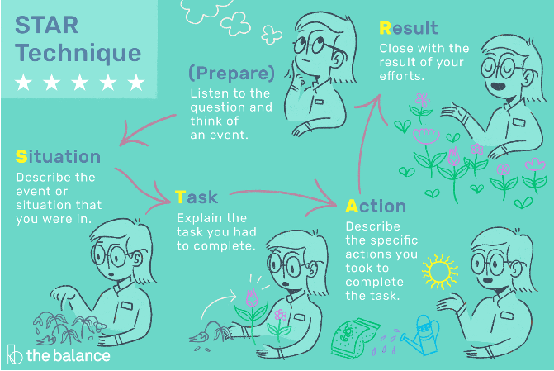

Example questions…
Tell me when you dealt with a difficult customer?
Tell me about a situation when you prioritised your work to meet a deadline?

Further information can be found at:
https://www.indeed.com/career-advice/interviewing/situational-interview-questions-and-answers#:~:text=Five%20situational%20interview%20questions%20and%20answers%201%20What,proud%20of%20and%20how%20did%20you%20achieve%20it%3F

What questions do you have for the employer?
Prepare some questions in advance. You can jot them down beforehand and check your notes when you’re asked this question.
Eg
- Where would I be based?
- Who will I be working with?
- How many people in the team?
- Will I have a uniform?
- What training will I receive?
- Will there be opportunities for progression in the future?
- When will I hear if I have been successful?

No questions left to ask?
If you don’t have any unanswered questions, say that you think they have answered all your questions, but can you contact them if there is anything you think of after the interview. This shows initiative!

After the Interview
Breathe a sigh of relief! You did the interview! Well done!

Did you get the job?
Yes - Fantastic! They will guide you through what happens next. Ask questions if you are unsure about anything.

No - Don’t worry, you usually need to do quite a few interviews to get a job, so see it as practice. Ask the employer to give you feedback on your interview in case there is anything you can improve on for next time.

If you fail to prepare, you prepare to fail

The 5 Ps - proper preparation prevents poor performance
SECTION 6:
Where to get help after SWRAC

CAREERS GUIDANCE / JOB HUNTING
- SWRAC– We can offer you support with information, advice and guidance for up to a year after you leave us.
Telephone: 01202 848099

BENEFITS AND JOB HUNTING SUPPORT
Job Centres:
- Bournemouth Jobcentre Plus
Tamarisk House, 1 Cotlands Road, Bournemouth, BH1 3BG
Telephone: 0845 604 3719 Textphone: 01202 276015
https://www.jobcentreguide.co.uk/bournemouth-jobcentre

- Lymington Jobcentre Plus
Cannon Court, Lymington, Hampshire, SO41 9AQ
Telephone: 0845 604 3719 Textphone: 0845 608 8551
https://www.jobcentreguide.co.uk/lymington-jobcentre

- Poole Jobcentre Plus
Old Town Market, Dear Hay Lane, Poole, Dorset BH15 1NZ
Telephone: 0800 169 0190
https://www.jobcentreguide.co.uk/poole-jobcentre

- Ringwood Jobcentre Plus
20-22 Southampton Rd, Ringwood, Hampshire, BH24 1DE
Telephone: 0800 169 0190 Textphone: 0845 608 8551
https://www.jobcentreguide.co.uk/ringwood-jobcentre

- Weymouth Jobcentre Plus
Westwey House, Westwey Road, Weymouth, DT4 8TG
Telephone: 0800 169 0190
https://www.jobcentreguide.co.uk/weymouth-jobcentre

- Winton Jobcentre Plus
609 Wimborne Road, Winton, Bournemouth, BH9 2AL
Telephone: 0845 604 3719 Textphone: 0845 608 8551

JOB HUNTING SUPPORT
- Seetec Pluss - www.seetecpluss.co.uk
Work and Health Programme - Department for Work and Pensions
Telephone: 0800 334 5525
Email: customersupport@seetecpluss.co.uk
Address:1a, Oxford Point, 19 Oxford Road, Bournemouth, BH8 8GS
Opening Times Monday - Friday (9am-5pm)

- SEND4 – www.send4.co.uk
Access supported employment
Job coaching
Travel training
Telephone: 07894 048839
Email: info@send4.co.uk
Covers Bournemouth, Christchurch, Dorset, Poole, West Hampshire

- Spear, Bournemouth— www.resurgo.org.uk
6-week short course to help you gain skills and confidence for the workplace.
For 16-24 year olds
Telephone: 07541 644 682
Address: Spear Bournemouth, St Swithun's Church, Gervis Road,
Bournemouth, BH1 3ED

- Up in BCP (youth support service) - https://www.upinbcp.co.uk/
www.upinbcp.co.uk or 07880 480 602

- Dorset Employment and Education Team (EET Support)
Tel: 01305 221783
Email: EETSupport@dorsetcouncil.gov.uk
Website: https://www.dorsetcouncil.gov.uk/education-employment-training-and-re-engagement-support-team

Access to Work
Access to Work can help you get or stay in work if you have a physical or mental health condition or disability.

Support for Paid Work
Access to Work can provide you with the support to need to be in paid work, including self-employment and working from home. Access to Work does not provide support for volunteers.

An Access to Work grant can help pay for things like:
- specialist equipment and assistive software.
- support workers, like a BSL interpreter, a job coach or a travel buddy.
- costs of travelling to work, if you cannot use public transport.
- adaptations to your vehicle so you can get to work.
- physical changes to your workplace.

Support is not means tested and the minimum number of hours you need to work is just one hour per week.

As part of Access to Work, you may be eligible for:
- a grant to help pay for practical support with your work,
- support with managing your mental health at work.

For these types of support, you must:
- have a physical or mental health condition or disability that means you need support to do your job or get to and from work,
- be 16 or over,
- be in paid work (or be about to start or return to paid work in the next 12 weeks).

Eligibility
You must have a disability, illness or health condition that means you need support to do your job. This can include, for example:
- a physical disability, for example if you’re hard of hearing or use a wheelchair
- a learning disability or related condition, for example if you have Down’s syndrome
- a developmental condition, like autism spectrum disorder
- learning difficulties or differences like ADHD or dyslexia
- an illness such as diabetes or epilepsy
- a temporary condition, like a broken leg
- a mental health condition, for example anxiety or depression
- You do not need to be diagnosed with a condition to apply.

For more information:
Website: https://www.gov.uk/access-to-work
Telephone: 0800 121 7479

This guide was created by:

Lorna Clark
Lead Careers Adviser



Updated February 2025

